SpectraGen
Spectrogram Image Generator
by Fatpigdog Industries
A subsidiary of Blueberry Technology, LLC

Revision 1.03

September 2012

Copyright 2011, Spyro Gumas

All Rights Reserved

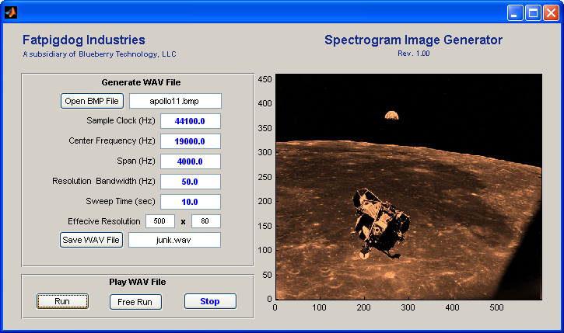

SpectraGen converts a bitmap image file (BMP, JPG, TIFF, etc) into a sound file (.WAV) suitable for generating an image on an acoustic spectrogram instrument. Preferebly, said instrument is Fatpigdog's Real Time FFT Spectrum Analyzer.

Quick Start Users Instructions

Generating a Spectrogram Image File
- Start the SpectraGen Program
- Click the Open Image File button and select an image file
- Use the default numeric values provided
- Click the Save WAV File button and provide a name for the WAV file which will be created
- Wait for the Processing, Please Wait .... message to vanish.

At this point SpectraGen has created a WAV file and saved it to the file & folder that you specified. The next step assumes that you have Fatpigdog's Real Time FFT Spectrum Analyzer for the purpose of generating the display. Any suitable acoustic, spectrogram capable spectrum analyzer will do given the appropriate configuration.

Transmitting, Receiving and Displaying a Spectrogram Image File
- Start the Spectrum Analyzer Program (this does not have to run on the same PC as SpectraGen).
- Configure the spectrum analyzer Center Frequency, Span, Resolution Bandwidth, and Sweep Time to match those values used by the SpectraGen program (displayed on the programs Graphical User Interface (GUI).
- Set the spectrum analyzer to Free Run (continuous operation).
- Transmit the spectrogram WAV file by clicking the Run button on SpectraGen program. Of course, at this point you can use any means of playing the WAV file that suits your purposes ... such as a Smart Phone, Personal Audio Player, or any audio software running on a PC.
- If you are using Fatpigdog's Real Time FFT Spectrum Analyzer, here are a few things that will help make the image stand out:
- Use the waterfall menu sofkeys to set the contrast and brightness. Use the Norm button to normalize the brightest displayable color to the peak value in the received signal. Use the Compress or Expand button to increase or decrease contrast respectively.
- Use the Rotate softkey under the waterfall menu to cause the waterfall to flow horizontally instead of the default vertical flow.
- Cycle through the Color Tables by clicking the button on the display, just to the right of the color bar. You may find that the best appearance occurs with the following color maps: Hot, Summer, Copper, Gray.

