Fatpigdog Industries

Real Time FFT Spectrum Analyzer
User’s Manual

Revision 3.35

January 2010

Copyright 2009-2010, Spyro Gumas
All Rights Reserved

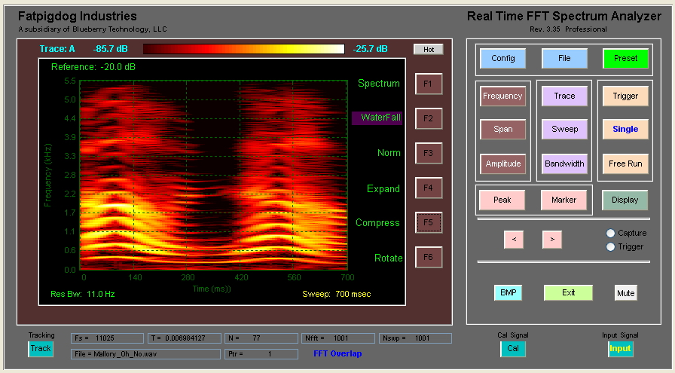
Spectrogram of little girl saying "Uh No"

Legal Notice and Disclaimer

Fatpigdog's Real Time FFT Spectrum Analyzer software is intended for hobbyist and casual use only. It is not a calibrated software instrument, and therefore any results produced can not and must not be used to provide quantified spectral and power measurements for commercial, medical, military, government, or any other official use.

Under no circumstances shall Fatpigdog's Real Time FFT Spectrum Analyzer software be used in a safety or life critical application.

No warranty is expressed or implied for the operation, usefulness, accuracy, or appropriateness of Fatpigdog's Real Time FFT Spectrum Analyzer. Neither Spyro Gumas, Fatpigdog Industries, Blueberry Technology, nor any affiliates or associates shall be held accountable, responsible, or liable for any consequences resulting from the use of Fatpigdog's Real Time FFT Spectrum Analyzer software.

License Agreement

The unregistered Free Trial version of the Real Time FFT Spectrum Analyzer may be freely distributed and used by anyone. There is a nag that appears every few minutes to remind the user of the right thing to do. Other than the nag, the Trial Version is fully functional, except restricts the ability to save configuration, default configuration, or BMP files of the display.

The Registered Professional Version of the Real Time FFT Spectrum Analyzer is licensed for use only by the person that paid for it and received the Registration Code. That lucky sole may install the software on up to two machines and even run them simultaneously ... Waaaa Hoooo. No sharing ... the kids gotta eat.

********************* System Requirements ****************
Operating Systems: Processors: Hard Disk: RAM :
Windows XP Sk 2 or 3 Intel Pentium 4 and above 680 MB** 512 MB
Windows Server 2003 SP 2 or R2 Intel Celeron*
Windows Vista SP 1 Intel Xeon
Windows Server 2008 Intel Core
AMD Athlon 64*
AMD Opteron
AMD Sempron*
* Processor must support SSE2 instruction set.
** Disk space requirement varies depending on size of partition. The Runtime installer will inform you of the hard disk space requirement for your particular partition. Installation size will be determined by the installer and can vary for NTFS and FAT formats.
Graphics:
16-, 24-, or 32-bit OpenGL capable graphics adapter

The User Interface.

Pretty self explanatory. Click on a Function (see Figure 1) button to select category. (such as Frequency, Amplitude, or Trigger).

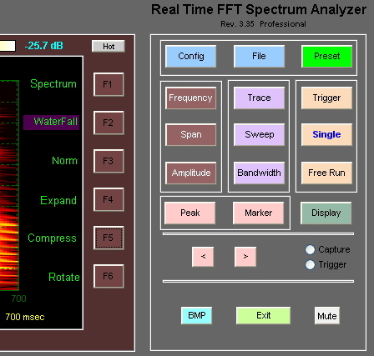
Figure 1 - Function Buttons and Soft Keys (F1 thru F6)

For most Function buttons, but not all Function Buttons, function option Soft Key descriptors will appear on the right hand side boundary of the display. The Soft Keys (F1, F2, ... F6) are to the right of the descriptors. Some of these Soft Keys will act on their own, others will require additional input.
If a Soft Key requires additional numerical value input, the Field Entry box (see Figure 2) will open up on the left side boundary of the display with the current value already highlighted and ready to be overwritten. At this point, the user can simply type and the value will overwrite the existing value in the edit box. This mechanism is provided as a short cut so the user need not click in the Field Entry box. A Function button may have some or all of its sub-menu Soft Keys as click-only, no Field Entry required.

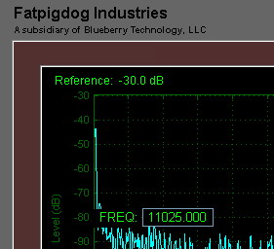
Figure 2 - Field Entry Box accepts user numeric input

Description of Function Buttons and their Soft Keys
The user selects a function from one of the Function Buttons provided on the Control Panel, shown in Figure 3. At that point, Soft Key options may appear on the right side display boundary, depending on the function selected. A detailed description of each Function Button and Soft Key follows.

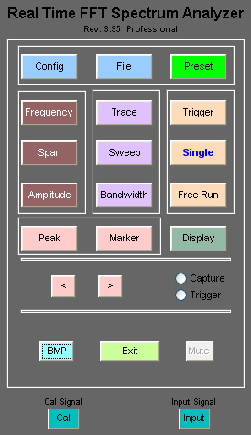
Figure 3 - Control Panel with Function Buttons

Config - The Config Function provides Soft Keys which the typical user may never want or need to use. However, these features can be useful for the advance user.
Tstupid - When data capture is initiated with the audio capture card in My PC, the initial gain response is zero, or pretty close to it. My audio card takes approximately 100 ms for its recording gain to stabilize. Tstupid is an advance in the amount of time that the spectrum analyzer captures data for a Single sweep, or for the first sweep of a Free Run. The captured data during the Tstupid interval is discarded. The user has access to this parameter to use at his peril. The default value is 100.
WFSwps - The default number of sweeps in Waterfall display mode is 100. WFSwps provides the user with the ability to change the number of sweeps captured in the time history of the waterfall.
Span/RBW - The default ratio of Span to Resolution Bandwidth (RBW) is 500. This is the value used in calculating the RBW in auto mode, relative to the selected span. Span/RBW provides the user with the ability to change this ratio.
Buffer - Clicking on the Buffer Soft Key opens up a new Soft Key menu shown in the following Buffer function section.
Memory - Clicking on Memory opens up three text fields underneath the display area (after a spectrum sweep). These three text fields are Max Array, Free Mem, and Mem Used and are primarily used for debug. The numbers reported here are in units of MBytes. MaxArray indicates the largest single consecutive block of memory available for an array, Free Mem is the number of MB free, and Mem Used is the number of MB currently used by the spectrum analyzer program.
Version - This provides a brief text screen with program identification, version, and copyright info.

Buffer - The Buffer function does not have its own function button, but instead is invoked by the Buffer Soft Key under the Config function. However, once invoked, it has Soft Keys just like other functions do. The Buffer referred to by this functionality is the audio FIFO (First In First Out) buffer in the audio card hardware. For those aware of the functioning of FIFOs, the functionality provided by the Buffer Soft Keys may be of interest. For the majority of users, the Buffer Soft Keys may be an area to stay away from. Note that the FIFO buffer is only operational for Live Input Mode.
ShowFifo - This causes a FIFO display to appear, showing real time status of the FIFO usage. The FIFO graphic shows the dynamic FIFO fill status between 0% to 100% percent. If and when the FIFO is flushed to 0%, this can be plainly seen.
AgeLimit - AgeLimit provides, in seconds, the amount of time for which audio may reside in the FIFO before it is to be considered Stale. Once data is stale, the FIFO buffer is flushed empty. This can occur when short FFTs are being executed (fast sweeps) imposing a large computational load on the processor. Of course, higher performance processors will suffer less than older, slower processors.
Blk Info - Clicking on Blk Info opens up three text fields underneath the display area (after a spectrum sweep). These three text fields are Age Limit, Block Size, and Blocks and these are primarily used for debug. Age Limit is the user specified AgeLimit parameter previously described. Block Size and Blocks are parameters that the user can not control, and they are descriptors of the Digital Acquisition FIFO (First In First Out) Buffer. The total number of samples in the FIFO is equal to Block Size x Blocks. The FIFO management subsystem automatically controls these parameters such that the FIFO never Overflows. It should be noted that for a given program instantiation (run), these parameters can only grow.
Back - Takes the menu system back to the Config function screen.

File - The File function provides the user with the ability to save and recall customized spectrum analyzer configurations. Configuration files are saved as type *.fpd.
Recall - Recall opens a browser and lets the user select a previously saved spectrum analyzer configuration file (*.fpd). If the spectrum analyzer is in Free Run mode before the Recall operation, it will continue in Free Run after the recall operation. Of course, all of the spectrum analyzer settings will be in the newly recalled configuration. Note that the saved audio sample data is also recalled and displayed on the spectrum or waterfall plot. If the Single function button is pressed before the Recall operation, then the saved data will available for trace operations, such as Hold or A->B (see Trace function button for trace operations). For example: press Single, then recall the configuration file, then click Trace, then select the desired trace (A or B) and select Hold. Then Free run with the other trace in Write mode. The real time trace can now be compared to the recalled trace.
Save - Save opens a browser and lets the user save the current spectrum analyzer configuration to a configuration file (*.fpd). If the spectrum analyzer is in Free Run mode before the Save operation, it will continue in Free Run after the Save operation. Note that the most recently sampled audio data is also saved.
Default? - The Default function is a specialized version of the Save function. The Default function asks the user to confirm that he wants to save the current spectrum analyzer configuration as the Default spectrum analyzer configuration. If a Default spectrum analyzer configuration file exists (default.fpd) in the start up directory when the Real Time FFT Spectrum Analyzer program is started, the spectrum analyzer will start up with the configuration that is defined by the saved default configuration. If the default.fpd file does not exist, the spectrum analyzer will start up in the factory default configuration, which is the same configuration that the Preset function invokes. Note that the most recently sampled audio data is also saved.
Save Audio - Save Audio opens a browser and lets the user save the most recently captured audio samples to an audio WAV file (*.wav). If the spectrum analyzer is in Free Run mode before the Save Audio operation, it will continue in Free Run after the Save Audio operation. Saved audio files can later be used as input data by selecting File Input from the Input function button.

Preset - The Preset function provide the user with a simple means to restore the configuration of the spectrum analyzer to the factory default settings, regardless of the existence of a default.fpd configuration file, and without necessitating that the program be closed and restarted. If the spectrum analyzer is in Free Run mode when the Preset function button is pressed, then the spectrum analyzer will continue in Free Run after it is pressed. Otherwise the spectrum analyzer configuration will be restored to factory default configuration but the analyzer will be in the stopped state, waiting to be run with either a Single or Free Run function press.

Frequency - Change center start and or stop frequencies. For Live audio input, the frequency limits of the spectrum analyzer are between 0 and 22.05 KHz, determined by ½ of the system’s sample clock frequency (Fs). For File Input, the sample clock is extracted from the file when it is opened. The Frequency range of the spectrum analyzer in File Input mode will be from 0 to ½ Fs Hz.
Center - This frequency goes to center of display
Start - Start frequency of a displayed Sweep (Far Left)
Stop - Stop Frequency (Far Right)
(Lin)/Log - Select linear or logarithmic frequency scale for the vertical frequency axis when the Spectrum display mode is selected. This feature is not (yet) available on the Waterfall display.

Span - Change the displayed frequency span. For Live audio input, the span limits of the spectrum analyzer are between 0 and 22.05 KHz, determined by ½ of the system’s sample clock frequency (Fs). For File Input, the sample clock is extracted from the file when it is opened. The Span limits of the spectrum analyzer in File Input mode will be from 0 to ½ Fs Hz.
Span - Displayed frequencies will range from Center Frequency +/- ½ Span
Full - Displayed Span will be fullest capability (Fs/2), where Fs default is 44100 Hz.
Zero - Zero Span. Signal is displayed as a Time / Amplitude plot (Oscilloscope mode). Note that the signal displayed will be filtered to satisfy the RBW constraint.

Amplitude - The user enters a reference level for the top grid line of the display. Division increments of the display can be selected from 10 dB per division, to 1 dB per division, or linear sampling. It is important to note that the amplitude levels indicated on the display are relative amplitudes, resulting from an uncalibrated microphone, amplifier, and analog to digital converter subsystem. The set Reference level is indicated at the top left boundary of the display.
Reference - Sets the signal displayed at the top of the screen, the reference level.
10 dB - Each vertical grid represents 10 dB (default)
5 dB - Each vertical grid represents 5 dB
1 dB - Each vertical grid represents 1 dB
Linear (P) - The vertical grid represents linear variation of power from Reference Level down to zero.
Linear (V)- The vertical grid represents linear variation of voltage from Reference Level down to zero. In this mode, two different color traces are simultaneously plotted. The Blue trace represents the I or In-Phase channel while the Red trace represents the Q, or Quadrature channel.

Peak - The Peak function places a small red symbol on the display at a frequency location where a peak amplitude is found. The Marker symbol “rides” the spectrum amplitude at the determined frequency. After selecting the Peak function, the Marker can be turned Off (and On again) using the Marker function Soft Keys. The Marker position can be moved by using the left and right arrow functions. The Marker Frequency and Amplitude are indicated at the top right boundary of the display. All Peak functionality operates on the Selected Active Trace as defined by the Trace (A) B Soft Key.
Find - Finds the peak amplitude within the displayed sweep and sets the marker to this position.
-> CF Sets the frequency of the indicated peak (where the marker is) to center.
Next R - Steps the marker right to the next signal peak which exceeds peak finding threshold to the right of the current peak.
Next L - Steps the marker left to the next signal peak which exceeds peak finding threshold to the left of the current peak.
Thresh - The peak finding threshold. Peaks below this value will not be found by the Peak sub functions. By default this value is set to -1000. When the Peak function is selected, the Peak Threshold is indicated on the bottom center boundary of the display.

Marker - The Marker function places a small red symbol on the display at a frequency location determined by the user. The Marker symbol “rides” the spectrum amplitude at the selected frequency. The Marker can be turned On and Off. The Marker position is set by using the left and right arrow functions. The Marker Frequency and Amplitude are indicated at the top right boundary of the display. All Marker functionality operates on the Selected Active Trace as defined by the Trace (A) B Soft Key.
Off - Turns off the marker
On - Turns on the marker
-> CF - Sets the spectrum analyzer Center Frequency to the frequency value of the current marker.

< (left) - Steps the Marker along the display towards the Left.

> (right) - Steps the Marker along the display towards the Right.

Trace - The Trace function provides the user with the ability to modify displayed trace data. There are three specific traces defined in the context of the Spectrum Analyzer operation. Two of the three traces (A and B) operate similarly, whereas the third trace displays the results of the Math functions defined below.
Trace (A) B - Selects Active Trace. The Trace operations listed below are performed on the Selected Active Trace (the one in the parenthesis). Note that in Spectrum Mode, each trace is drawn in a unique trace color. In Waterfall Mode, if the Math Trace is hidden, then the selected active trace (A or B) is displayed on the waterfall. If Math Trace is not hidden, then Waterfall displays the results of the Math Trace.
Write - A new trace is written for each sweep.
(Max)/Min - If (Max), the trace holds the maximum values. The highest amplitude is displayed for each frequency. If (Min), the trace holds the minimum values. The lowest amplitude is displayed for each frequency.
Average - The displayed sweep is a running average of current and previous sweep values. The number of averages is displayed at the top center boundary of the display.
(Hold)/Hide - If (Hold), the trace Holds. Trace updates cease. If (Hide), the trace is hidden from view (and for the purpose of Math operations, “holding” not updating).
Math - Selects a new set of menu options for the third type of trace, the Math Trace (another unique color for this trace).

Math
Norm - Normalizes the A trace by the B trace and displays the result as a new trace in a unique color. Normalization occurs by performing sample by sample divide of A samples by B samples, prior to conversion to dB. This is equivalent to subtracting the B Trace values in dB from the A trace values in dB. Normalization is extremely useful for removing the effects of a non-flat frequency response (stored in B Trace) from the A trace.
A + B - Computes the summation of the A trace with the B trace on a sample by sample basis, prior to conversion to dB. Caution – this is not a sum of dB values !
A – B - Computes the difference, or the A trace minus the B trace on a sample by sample basis, prior to conversion to dB. Caution – this is not a difference of dB values !
A -> B - This operation copies the A trace values into the B Trace. The best way to do this is to have both the A and B traces on “Hold” prior to executing the copy. Doing so insures that the A trace is stable with the important trace data, and also insures that once copied, the B trace will not immediately change.
(Hold)/Hide - If (Hold), the trace Holds. Trace updates cease. If (Hide), the trace is hidden from view.

Back - Returns the user back to the Trace menu options.

Sweep - Sweep is the interval of time used to collect the raw data, upon which spectral analysis is performed to produce the displayed power spectrum. A traditional swept spectrum analyzer sweeps its local oscillator from the start frequency to the stop frequency over the Sweep time interval. The result for these traditional analyzers is that activity may be missed at a specific frequency if it happens to be inactive during the moment when the local oscillator sweeps through that specific frequency. The Real Time FFT Spectrum Analyzer works differently. Data is collected into a buffer over the duration of the Sweep time interval. Then the entirety of the data is processed with a Fast Fourier Transform (FFT). With this approach, the complete spectral content of the data captured during the Sweep time interval is determined and displayed (nice). The Sweep time interval is shown on the bottom right boundary of the display.
Auto - Lets the spectrum analyzer chose the optimal Sweep Time. Refer to Appendix A for how Sweep Time is determined.
Time - Manually sets the sweep time in milliseconds.

Bandwidth - Bandwidth refers to the Resolution Bandwidth (or RBW) with which the spectrum analyzer produces its results. The user should take care to insure that the RBW is small enough to provide spectrum plots with sufficient spectral (frequency) granularity for the desired purpose. The RBW is shown on the bottom left boundary of the display.
Auto - Lets the spectrum analyzer chose the optimal Resolution Bandwidth. Refer to Appendix A for how Bandwidth is determined.
RBW - Manually sets the resolution bandwidth in Hz.
Hamming - When Hamming is selected (Hamming!) the a Hamming taper is applied to the raw analog input data prior to computing the spectrum. This has the effect of reducing the spurious side lobes of the displayed spectrum. However it also has a subtle broadening effect on the desired spectral components of the display.
Overlap- With Overlap selected (Overlap!), the FFT Overlap feature is enabled for Waterfall displays (only). See discussion of FFT Overlap in the last section of this document.

Trigger - Trigger is that which makes the spectrum analyzer "go". When the spectrum analyzer starts up, the default is for it to be in Free Run mode. The user can change this through the use of the Trigger, Single, and Free Run functions. All Trigger functionality operates on the Selected Active Trace as defined by the Trace (A) B Soft Key.
Free - The spectrum analyzer continually triggers as fast as it can, generating a sweep as fast as it can. This speed (or revisit time) is determined by the value of Sweep time plus the time it takes for the software to process and display the sweep result.
Video - The spectrum analyzer only triggers a new sweep if a signal level is detected equal to or greater than the trigger threshold, set by clicking the video button and entering the threshold in the input field. When the Trigger function is selected, the Video Trigger threshold level is indicated on the bottom center boundary of the display. By default this value is set to the minimum displayed Amplitude level.
Show - Shows a dotted horizontal line on the display, at the Video Trigger threshold level. The line is only displayed when Video trigger mode is selected. If the trigger level is achieved and the spectrum display is updated, the line is Blue. If no trigger occurs, the line is drawn in a Maroon color.

Single - The Single function causes exactly one frequency sweep to occur and updates the display. This is if course also governed by the Trigger Function settings.

Free Run - The Free Run function causes the analyzer to continuously update and display frequency sweeps (default mode when started). To exit the Free Run mode, select the Single function. This is if course also governed by the Trigger Function settings.

Display
Spectrum - Traditional Spectrum Analyzer display mode (Amplitude vs. Frequency) as shown in Figure 4. In Spectrum display mode, the Trace menu item lets the user select up to three simultaneous traces to be displayed, Trace A, Trace B, and the Math trace.

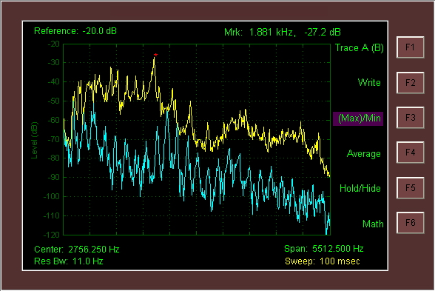
Figure 4 - Spectrum Display, shown with Trace function Soft Keys

Waterfall - Waterfall display (Frequency vs. Time) as shown in Figure 5. In this mode the time history of the spectrum is displayed as it changes as a result of a chirping bird, modulating voice, or what have you. The two dimensions are employed for frequency and time, with Power being indicated in the color dimension, utilizing a color "rainbow", which in the case of "Jet" ranges from dark blue for the weakest signal strength to red for the strongest signal strength. Clicking on the button to the right of the displayed color bar causes the Color Map to cycle through the various available options.

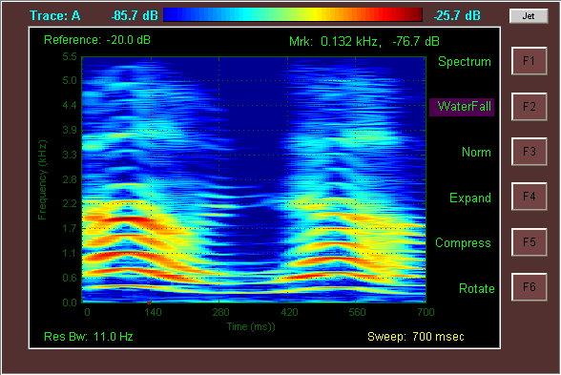
Figure 5 - Waterfall Display, shown with Display function Soft Keys

In Waterfall display mode, only one trace can be selected to drive the display. If the Math trace is enabled (not hidden) then it is the source of the display data. Otherwise the active selected trace (A or B) is the source of the waterfall display, regardless of the “Hide” status of A or B trace. the Trace menu item lets the user select up to three simultaneous traces to be displayed, Trace A, Trace B, and the Math trace. [Note that if the Amplitude function is set up with its Soft Keys for one of the two Linear options, Waterfall Display is not fully worked out yet ...].
Norm - Only shown in Waterfall Mode. By default, the signal strength color scale is mapped from the Amplitude Reference level (Red) down to 100 dB less for dark Blue. Norm maps Red, the "hottest" color, to the maximum signal power level displayed on the screen at the time that the user clicks the Norm Soft Key.
Expand - Only shown in Waterfall Mode. The default signal strength range for the color scale is 100 dB. Each click of Expand expands the mapped signal strength range which is mapped onto the Dark Blue to Red color scale by M dB. M is determined by the mode selected under the Amplitude function. If 10 dB is selected under the Amplitude function, then M = 10 dB.
Compress - Only shown in Waterfall Mode. The default signal strength range for the color scale is 100 dB. Each click of Compress compresses the mapped signal strength range which is mapped onto the Dark Blue to Red color scale by M dB. M is determined by the mode selected under the Amplitude function. If 10 dB is selected under the Amplitude function, then M = 10 dB.
Rotate - Only shown in Waterfall Mode. The default waterfall orientation is a vertical, up scrolling display with time going along the vertical axis and frequency along the horizontal axis. Clicking the Rotate Soft Key changes the orientation to a left horizontal scrolling display with time going along the horizontal axis and frequency going along the vertical axis. Each clock of Rotate Soft Key switches back and forth between these two choices.

Tracking - Tracking is a swept acoustic tone that is enabled to play through the PC speakers. The start frequency of the swept tone is the start frequency of the displayed frequency span. Likewise the stop frequency of the swept tone is the stop frequency of the displayed frequency span.
(On) / Off - Turns the Tracking Generator on and off.
Tracking Generator Caveats:
1) The design of the tracking generator is such that the swept tone loosely follows the sweep timing programmed with the Sweep function. There is a bit of an asynchronous relationship between the capture subsystem (which listens to audio) and the tracking generator (which plays audio). Therefore, there can be situations where the tracking generator starts before the capture starts, or ends after the capture end, or both. More importantly, Tstupid (see discussion on Config function) may make things difficult when using the Single function, as opposed to Free Run.
2) This is a monophonic tone that is played through both left and right channels. The user should take this fact into consideration when making any measurements since constructive and/or destructive interference will occur between the tones from the two speakers at the location of the single microphone, dependent on the specific locations of these three elements .... and any reflections off of walls, ceiling, your forehead ... :-)... etc. Hint, turn the audio balance all the way left or right.

Cal - Calibration is an acoustic tone that is enabled to play through the PC speakers.
(On) / Off - Turns the fixed acoustic calibration tone on and off. The calibration tone frequency is specified via the Frequency Soft Key.
Frequency - The calibration tone frequency is set with this Frequency Soft Key. The default calibration tone frequency is 15 kHz.
Calibration Caveat:
This is a monophonic tone that is played through both left and right channels. The user should take this fact into consideration when making any measurements since constructive and/or destructive interference will occur between the tones from the two speakers at the location of the single microphone, dependent on the specific locations of these three elements .... and any reflections off of walls, ceiling, your forehead ... :-)... etc. Hint, turn the audio balance all the way left or right.

More Hints - Have a teenage daughter? Set the Calibration tone to17 Hz and the sweep time to1 sec. Make sure all sharp tools have been locked up :-)

Input - The can chose between analysis of real time data coming in to the spectrum analyzer through the microphone input, and pre-recorded data coming from an audio *.wav file. The Input function button permits the user to select between these two sources.

File Input - Clicking this selects the Audio *.wav file input mode and causes the Soft Key submenu options to change as indicated below. Additionally, the Filename and Ptr text boxes appear along the bottom edge of the Spectrum Analyzer program window.
---------------------
Live Input - Selects the PC’s audio microphone as the real time input source.
SampleClk - When opening a .wav file, the sample frequency is known and embedded within the .wav file. The Sample Clock (Fs) gets set automatically. This button lets the user optionally override the sample clock frequency.
Filename - The user clicks here to open up a file browser and select the audio wave file to analyze. The name of the selected file appears in the Filename text box along the bottom edge of the Spectrum Analyzer program window. The first time the user switches to File Input mode, the spectrum analyzer will stop since no file has yet been selected for analysis. After the user selects a file, it will remain in effect as the user toggles back and forth between Live Input and File input (i.e. the analyzer will not be forced to stop running).
Pointer - As the selected file is read in and analyzed, the file pointer is displayed in the Ptr text box along the bottom edge of the Spectrum Analyzer program window. The Pointer Soft Key provides the user with the ability to force the file pointer to a particular section of the file. The user provides the desired pointer value in percentage of complete file. So entering ‘10’ will force the pointer to 10% mark of the file.

BMP - BMP lets you save a BMP bitmap file of the spectrum analyzer display.

Mute - When the spectrum analyzer Input function is used to select File Input mode, the audio of the selected file can be heard through the speakers of the PC. The Mute Function button is provided so the user can mute the audio easily, without needing to open the operating systems volume control utility.

Exit - Exits the application.

Indicators Lights

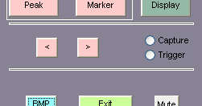
Figure 6 - Capture and Trigger Indicator Lights

Capture - The Capture light shown in Figure 6 illuminates while the spectrum analyzer captures data from the audio input (microphone, or file). The Capture light will illuminate for the duration of the Sweep time interval.
Trigger - After data is captured for each sweep, it is tested against a level threshold to see if it meets the trigger condition set by the Trigger function button. If the trigger condition is met, the Trigger light shown in Figure 6 illuminates briefly for that sweep.

Miscellaneous Information Fields

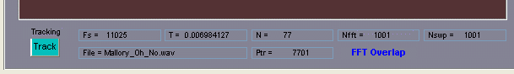
Figure 7 - Miscellaneous information fields

The data provided in the miscellaneous information fields shown in Figure 7 is provided for the more curious user, and more importantly they were provided for debug purposes for the author and now he is too attached to them to remove them. Some are more useful than others, and some are down right esoteric.

Fs - Fs is the sample clock frequency. For Live input mode, it is forced to 44.100 KHz. For File input mode, Fs is determined by the wav file.
T - T is the Sweep time interval in seconds.
N - N is the number of samples captured during the Sweep time interval. N is equal to Fs*T, rounded to the nearest integer.
Nfft - Nfft is the number of samples used for the FFT calculation. Nfft is determined by the required RBW.
Nswp - Nswp is the number of frequency samples that are plotted on the display.
File - File is the filename that was selected by the user and that is used for File Input mode.
Ptr - In File Input Mode, as the analyzer reads in the selected file, Ptr increments to provide an indication of what portion of the file is currently being read. The unit of measure for the indicated Ptr is blocks.
FFT Overlap - FFT Overlap is an indicator message that comes on in Waterfall Display mode if the selected RBW is finer than can normally be supported by the selected Sweep time interval. If the RBW is too fine, than the spectrum analyzer enters into Overlapped FFT mode, whereby Nfft is greater than N to provide the necessary frequency resolution. Each Nfft point FFT is stepped in overlapping time segments, where the percentage of time overlap is equal to 100*(Nfft-N)/Nfft. The net effect of overlap is that one achieves the desired frequency resolution at the expense of reduced time resolution. The overlap effectively smears the time resolution of the displayed waterfall data.

Appendix A
Determination of Sweep Time and Resolution Bandwidth
Sweep Time and Resolution Bandwidth (RBW) are tightly coupled through signal processing theory. The best frequency resolution that one can achieve is limited and determined by the inverse of the time duration of the captured sample data. What this means is that if you have need a RBW of 10 Hz, you need to set Sweep Time to at least 1/10 or 100 ms. Attempting to achieve finer time resolution (faster Sweep Times) will cause an inversely proportional degradation in RBW.
The Spectrum Analyzer software allows the user to select Auto or user input modes for both Sweep Time and RBW, while doing its darndest to satisfy the laws of physics. In Spectrum Display mode (and assuming Non-Zero Span), the following logic is applied in determining the operating parameters:

Sweep = Auto | RBW = Auto
RBW = SPAN / "SPAN/RBW" (See Config Function)
SWEEP = 1/RBW
Sweep = Auto | RBW = User Input
RBW = User Input
SWEEP = 1/RBW
Sweep = User Input | RBW = Auto
SWEEP = User Input
If 1/SWEEP > SPAN / "SPAN/RBW" (See Config Function)
RBW = 1/SWEEP
Else
RBW = SPAN / "SPAN/RBW" (See Config Function)
Sweep = User Input | RBW = User Input
SWEEP = User Input
If 1/SWEEP > RBW
RBW = 1/SWEEP
Else
RBW = User Input

In Waterfall Display mode, and if only FFT Overlap is enabled (see Bandwidth Function), then if the selected RBW is finer than can normally be supported by the selected Sweep Time, the spectrum analyzer enters into Overlapped FFT mode, whereby Nfft is greater than N to provide the necessary frequency resolution. Each Nfft point FFT is stepped in overlapping time segments, where the percentage of time overlap is equal to 100*(Nfft-N)/Nfft. The net effect of overlap is that one achieves the desired frequency resolution at the expense of reduced time resolution. The overlap effectively smears the time resolution of the displayed waterfall data.

